Machine Learning Model Deployment with IBM Cloud Watson Studio
Phase – 5(Documentation)

Abstract
This project leverages IBM Cloud Watson Studio to develop and deploy predictive models for customer churn analysis in the telecommunications industry. By collecting and analyzing customer data, training machine learning models, and integrating them into operational systems, the project aims to proactively reduce churn rates and enhance customer retention strategies.

Problem Statement
Become a wizard of predictive analytics with IBM Cloud Watson Studio. Train machine learning models to predict outcomes in real-time. Deploy the models as web services and integrate them into your applications. Unlock the magic of data-driven insights and make informed decisions like never before!

Problem Definition
The project involves training a machine learning model using IBM Cloud Watson Studio and deploying it as a web service. The goal is to become proficient in predictive analytics by creating a model that can predict outcomes in real-time. The project encompasses defining the predictive use case, selecting a suitable dataset, training a machine learning model,deploying the model as a web service, and integrating it into applications.

DATASET COLLECTION:
Customers who left within the last month (Churn):
This column indicates whether a customer terminated their relationship with the company within the past month. This information is crucial for businesses, as it helps them understand customer attrition rates. Analyzing churn can provide insights into factors that lead to customer dissatisfaction or reasons for discontinuing services.
Services that each customer has signed up for:
This section details the specific services that each customer has subscribed to. These services may include phone lines, multiple phone lines, internet services, online security, online backup, device protection, tech support, and streaming TV and movie packages. Understanding which services are popular among customers can guide marketing efforts and product development.
Customer account information:
This section encompasses various details related to the customer's account and usage:
- Tenure (how long they’ve been a customer): Indicates the length of time a customer has been with the company. Long-tenured customers are often seen as more valuable due to their loyalty and potential for continued business.
- Contract: Specifies the type of contract the customer has (e.g., month-to-month, one-year, two-year). Different contract types may have implications on customer behavior and revenue stability.
- Payment method: Describes how the customer pays for the services (e.g., credit card, electronic transfer). This information is important for billing and financial management.
- Paperless billing: Indicates whether the customer opts for paperless billing, which can have environmental and cost-saving implications for the company.
- Monthly charges: Specifies the amount the customer is billed on a monthly basis for the services they've subscribed to.
- Total charges: Represents the cumulative charges incurred by the customer over their tenure with the company.
Demographic info about customers:
This section provides additional information about the customers' characteristics:
- Gender: Indicates whether the customer is male, female, or of another gender identity. This information can be useful for targeted marketing campaigns.
- Age range: Categorizes customers into specific age groups (e.g., 18-24, 25-34, etc.). Understanding the age distribution can help tailor products and services to different demographic segments.
- Partners and dependents: Indicates whether the customer has a partner (spouse or significant other) and if they have dependents (children or other individuals they financially support). This information is valuable for family-oriented marketing strategies and understanding household dynamics.
Analyzing these aspects collectively can provide valuable insights into customer behavior, preferences, and potential areas for improvement in services or marketing strategies.
APPROACH:

Data Collection and Preprocessing: To build a customer churn prediction model, historical customer data is collected. This data typically includes information such as customer demographics, usage patterns, contract details, billing information, and records of customer service interactions. It is crucial to clean and preprocess this data, addressing issues like missing values and outliers.

Model Selection: The choice of machine learning algorithms plays a crucial role in building the predictive model. Common algorithms used for this purpose include logistic regression, decision trees, random forests, gradient boosting, and more. The selection of the appropriate algorithm depends on the specific characteristics of the dataset and the business objectives.

Model Training and Evaluation: The predictive model is trained using historical customer data, with a focus on identifying patterns and trends associated with customer churn. The model's performance is assessed using various metrics, including accuracy (the percentage of correct predictions), precision (the percentage of true positives among predicted positives), recall (the percentage of true positives identified), F1-score (a balance between precision and recall), and ROC-AUC (Receiver Operating Characteristic - Area Under the Curve).

Churn Prediction: Once the model is trained and validated, it can be applied to new customer data. For each customer, the model calculates the probability of churn. Customers with high churn probabilities are flagged as at-risk churners.

Retention Strategies: The predictions generated by the model are instrumental in devising retention strategies. For customers identified as high-risk churners, personalized offers, discounts, or incentives can be extended to encourage them to remain loyal to the telecom service.

Deployment: The churn prediction model is integrated into the telecom company's operational systems to enable real-time predictions and automate intervention processes. This ensures that retention efforts can be initiated promptly.

Monitoring and Iteration: The model's performance is continuously monitored, and it is regularly updated with new data. As customer behavior may change over time, this iterative process helps in maintaining the model's accuracy and relevance. Retention strategies are also adjusted based on feedback and evolving customer preferences.

PHASE 3:

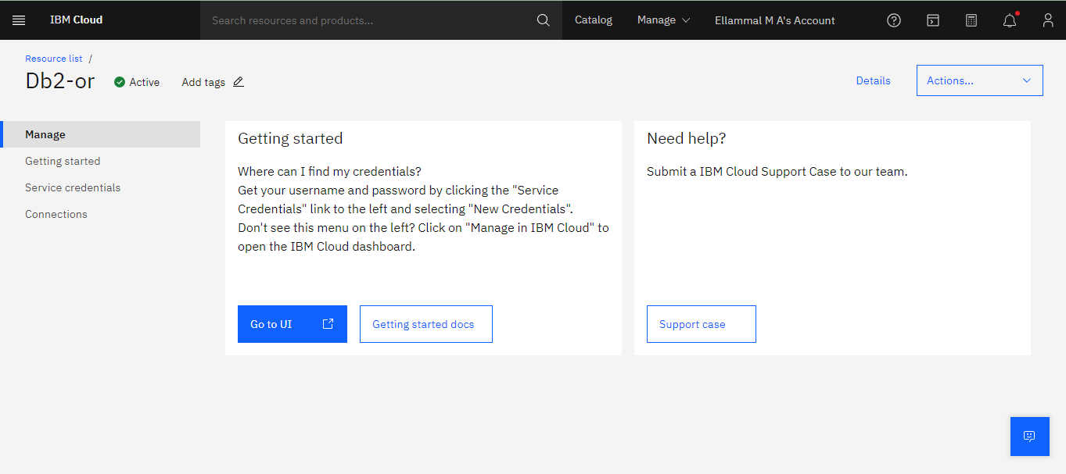

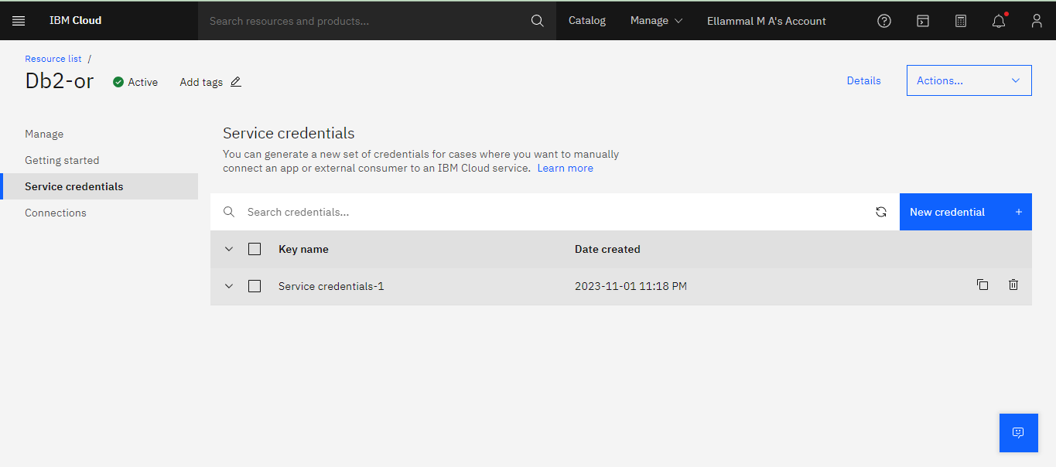

"-u",
"dbm63932",
"-p",
"W3KPfJv9swuf699o",
"--ssl",
"--sslCAFile",
"1dd14d0c-1b52-4f63-a606-53ecba28771d",
"--authenticationDatabase",
"admin",
"--host",

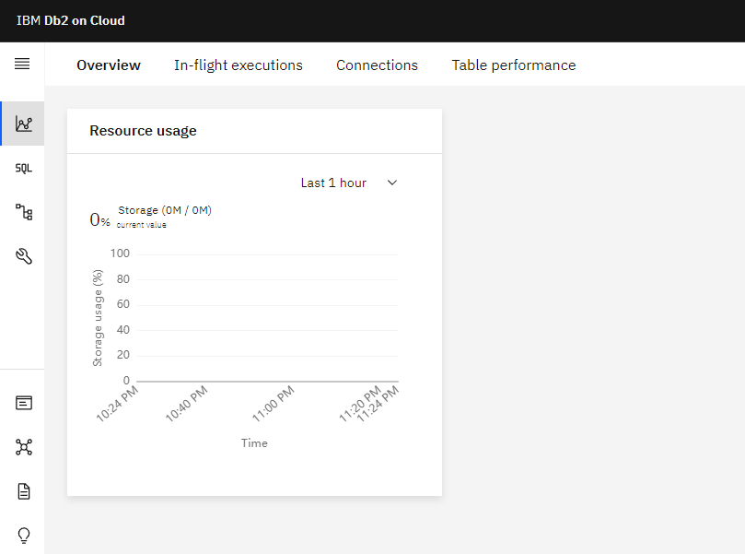

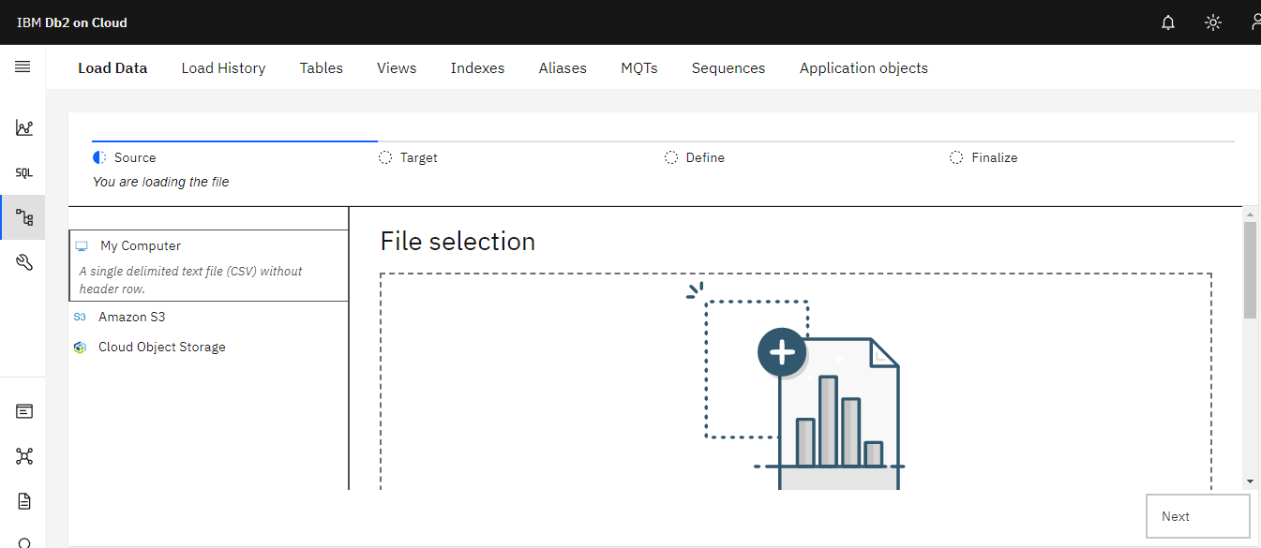

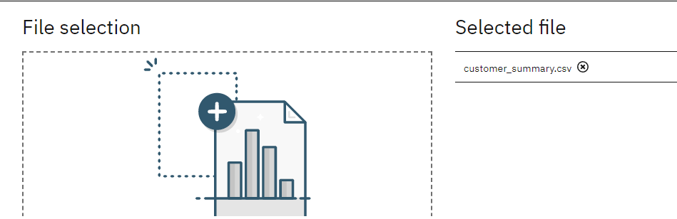

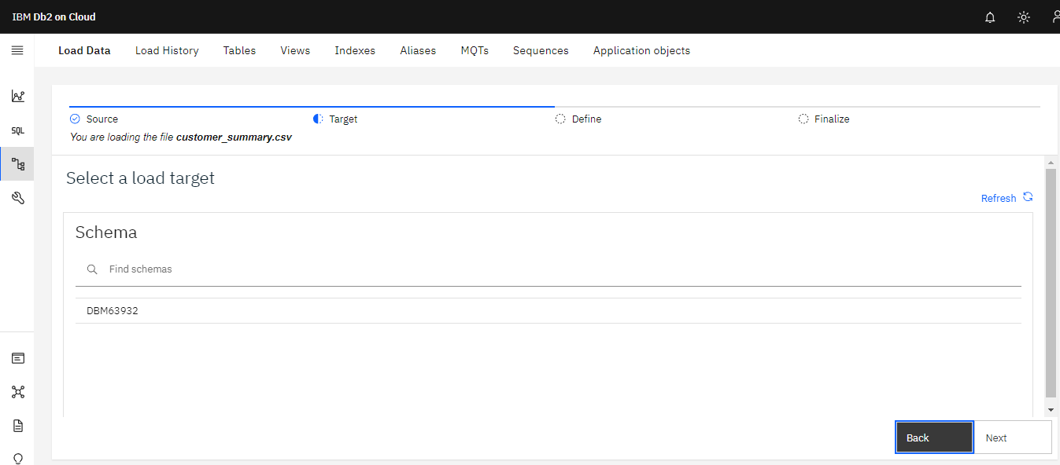

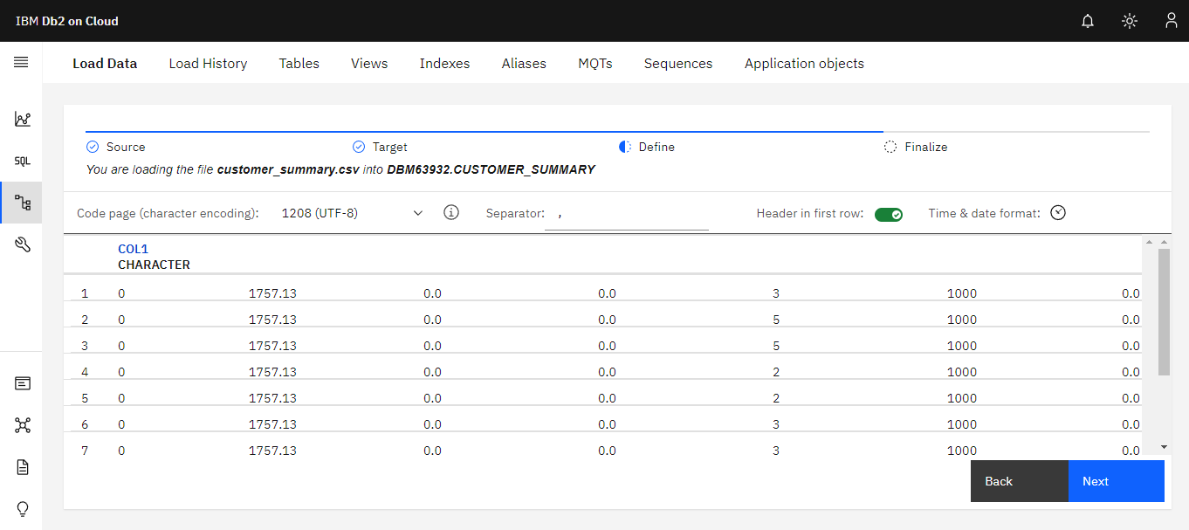
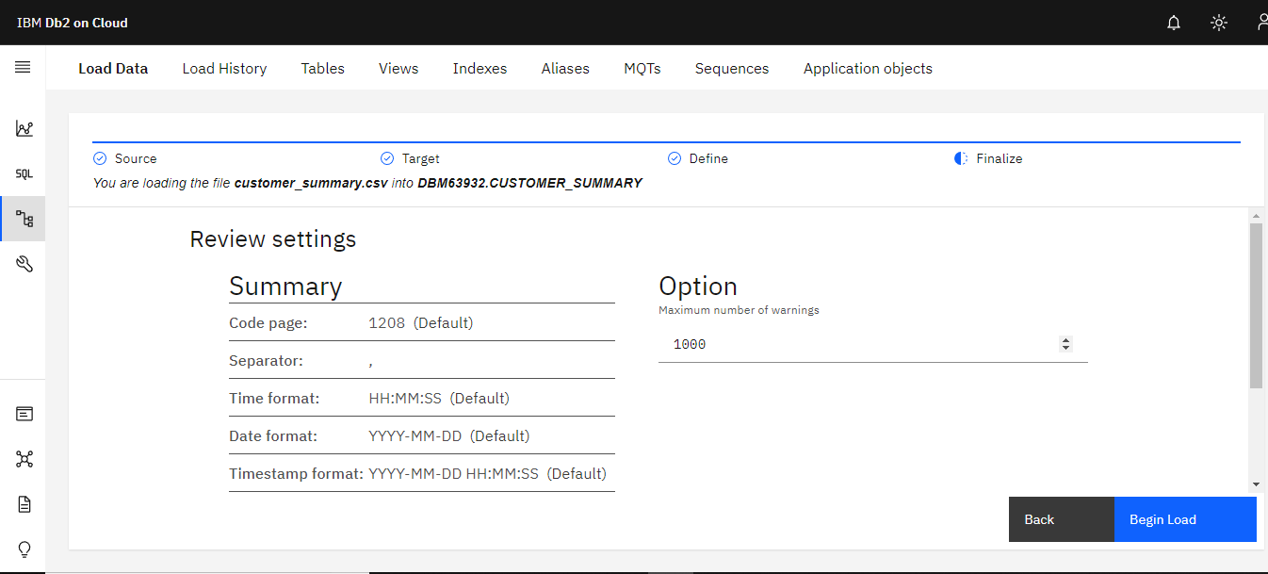

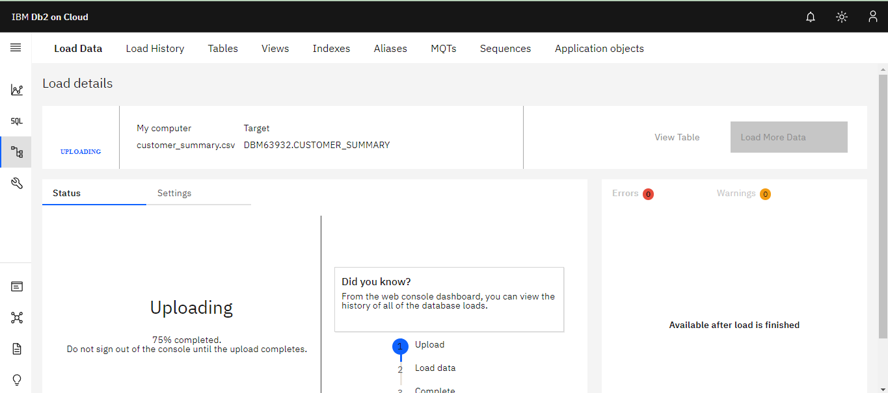
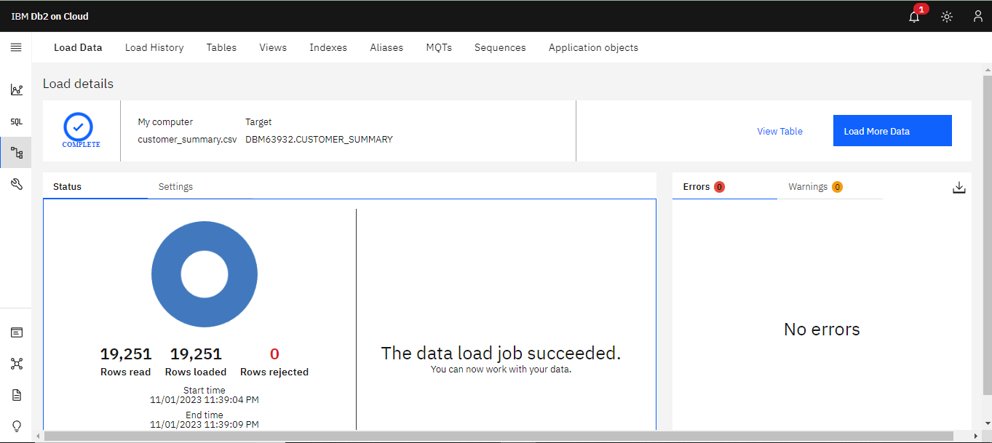

PHASE-4
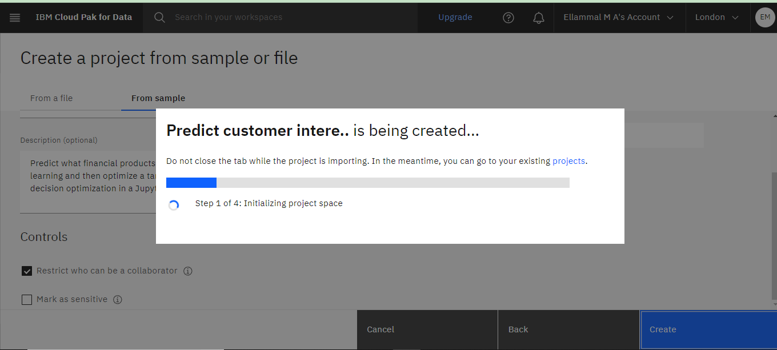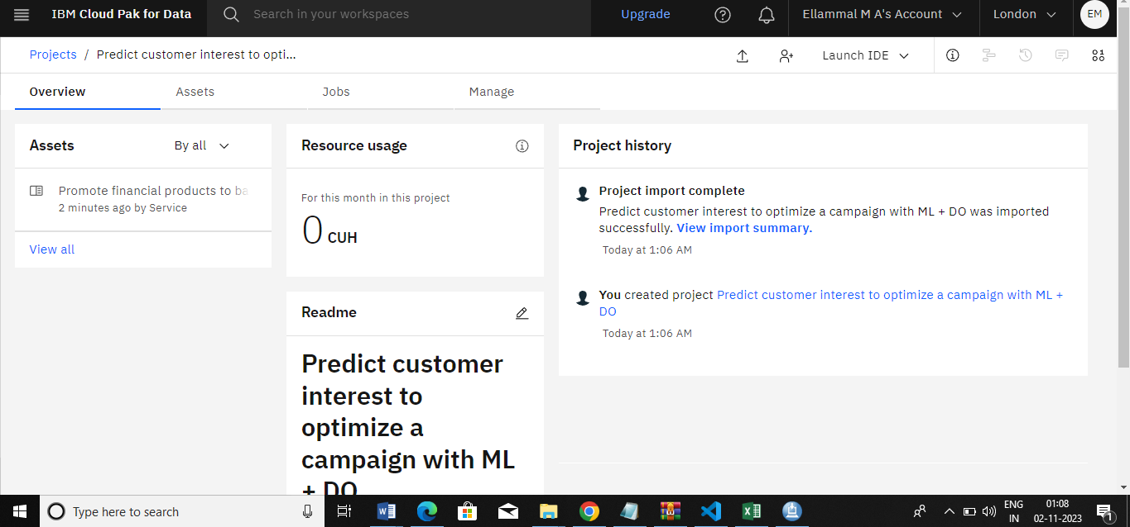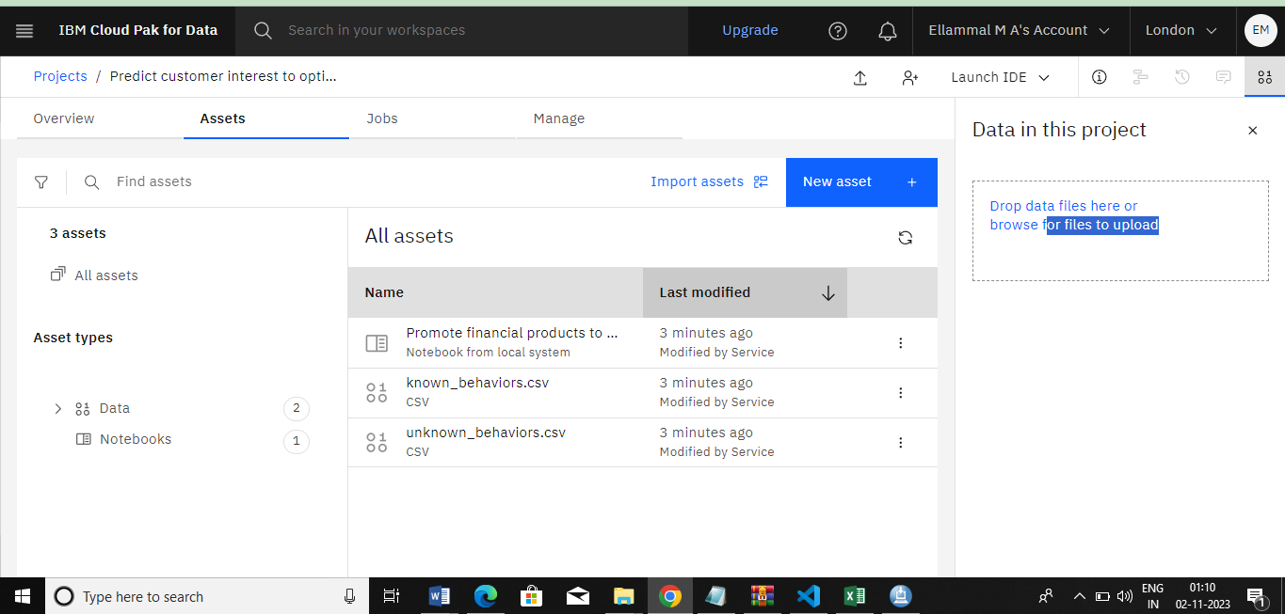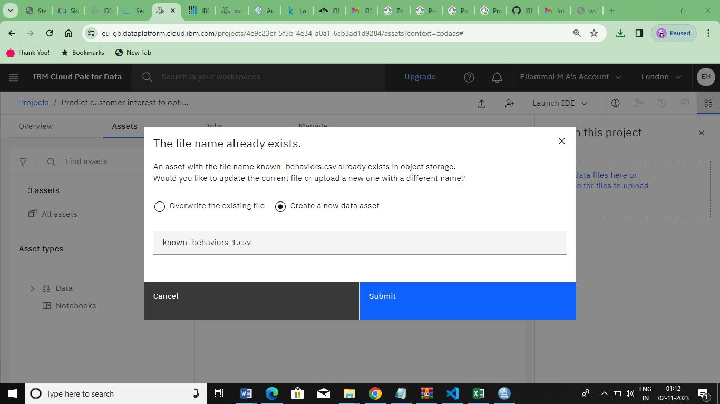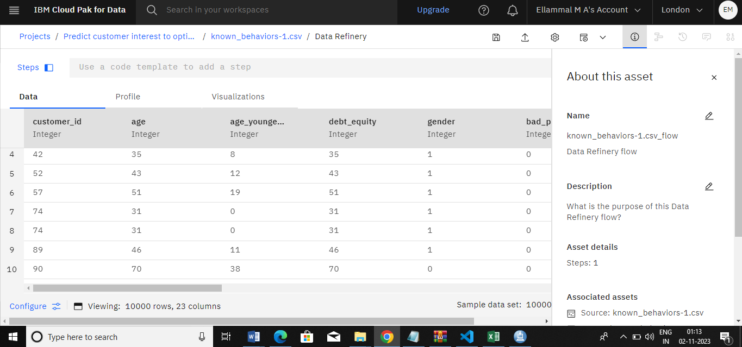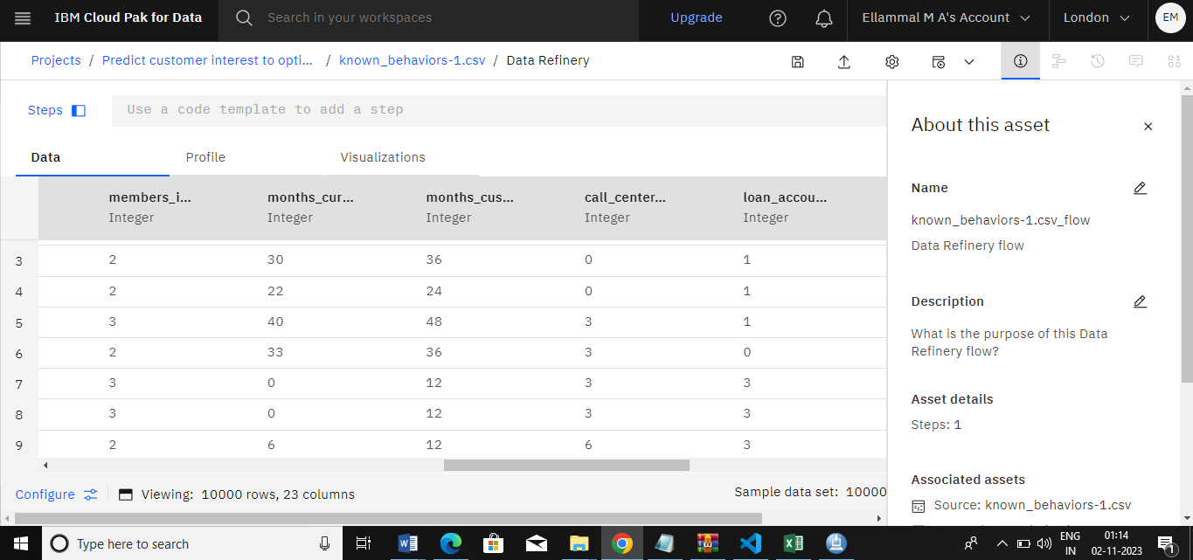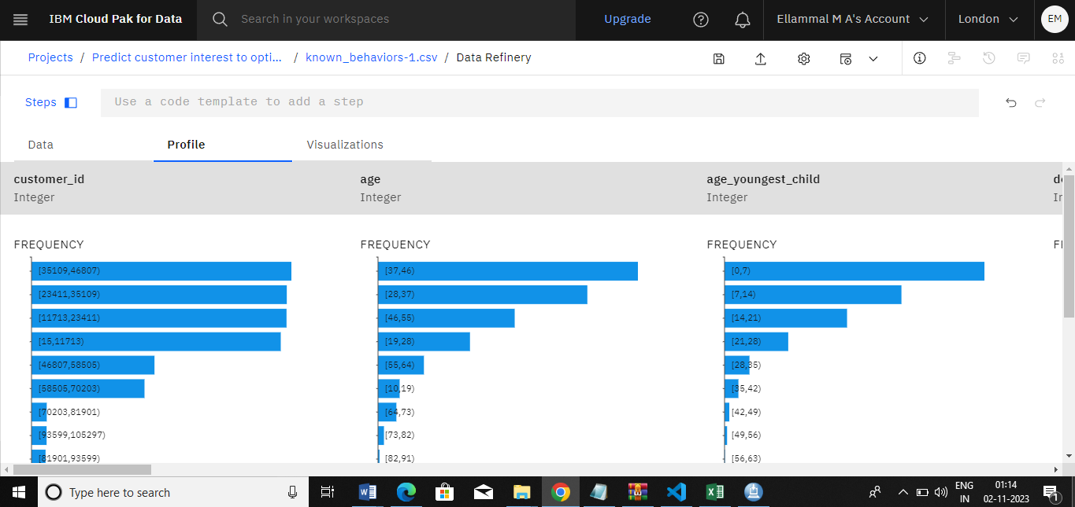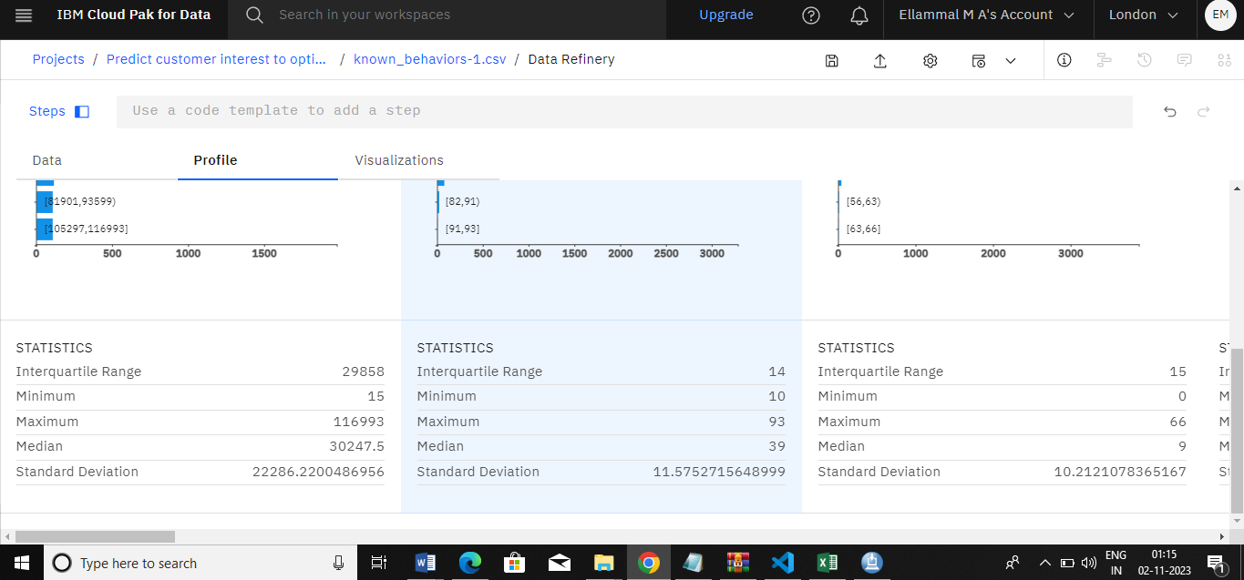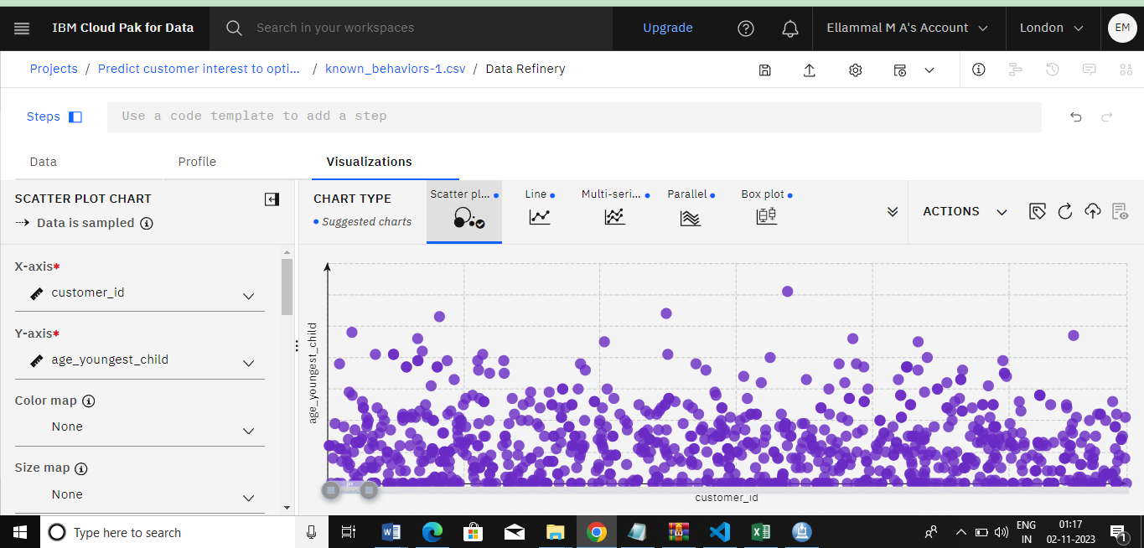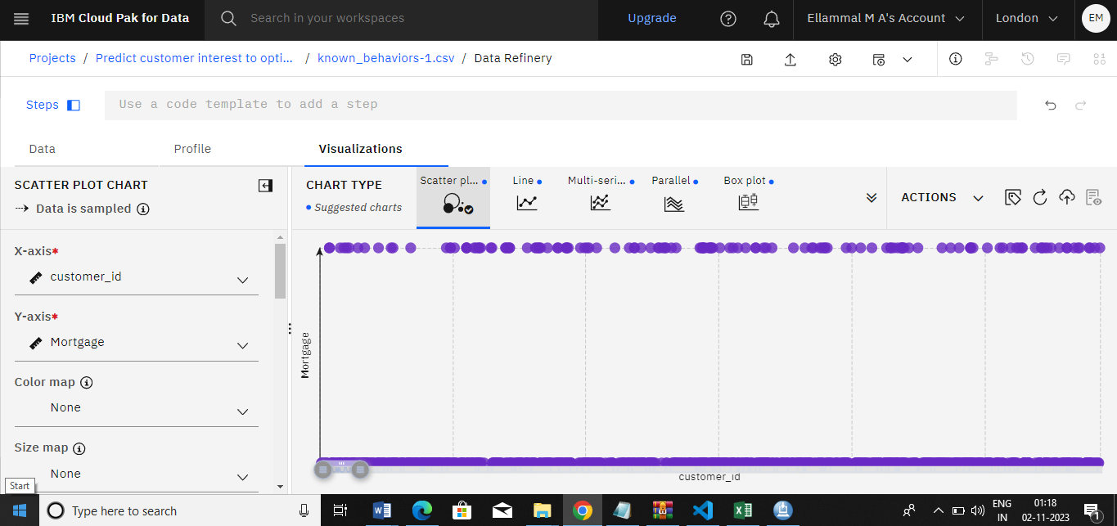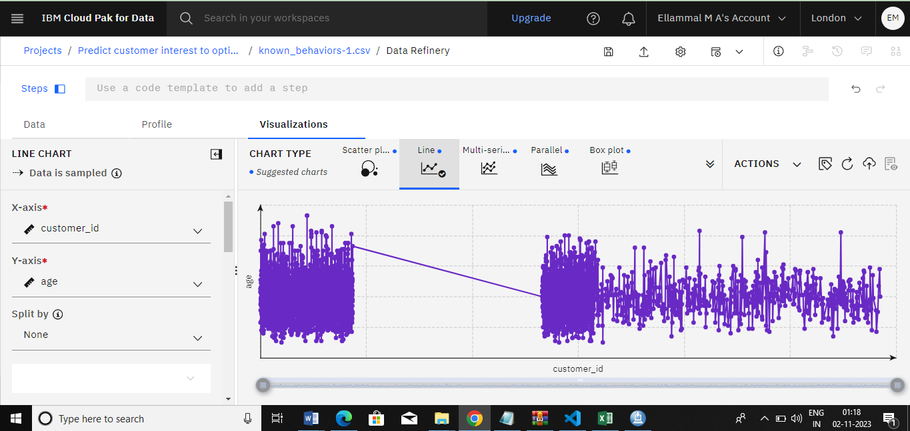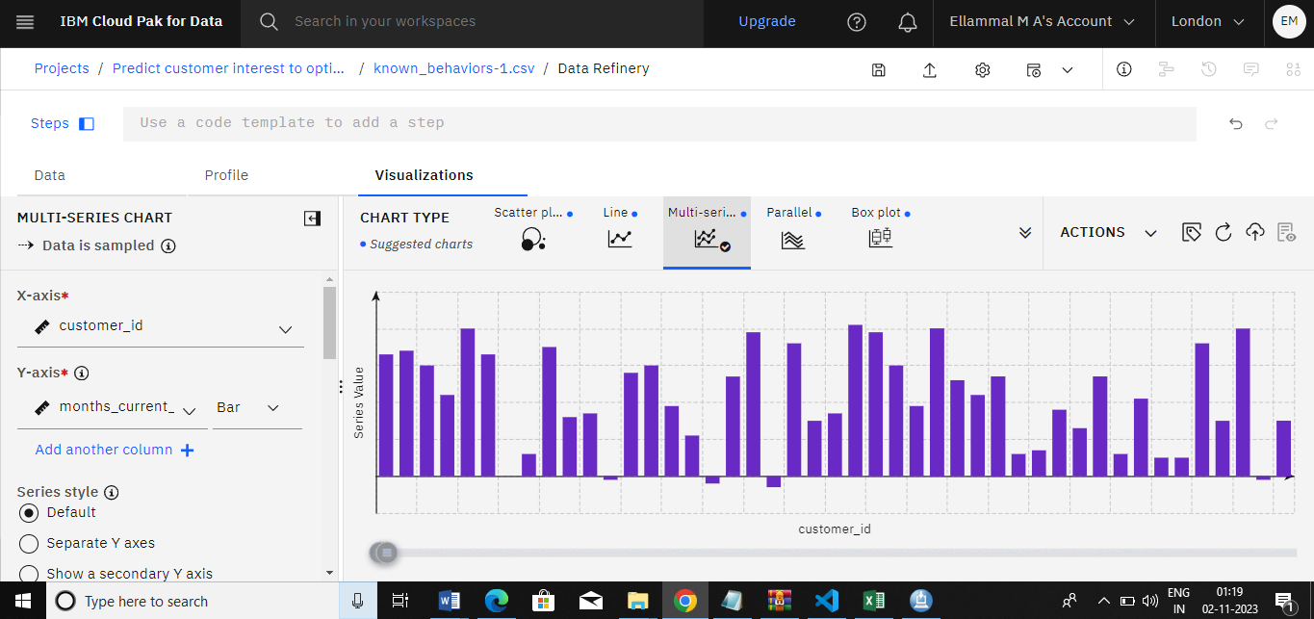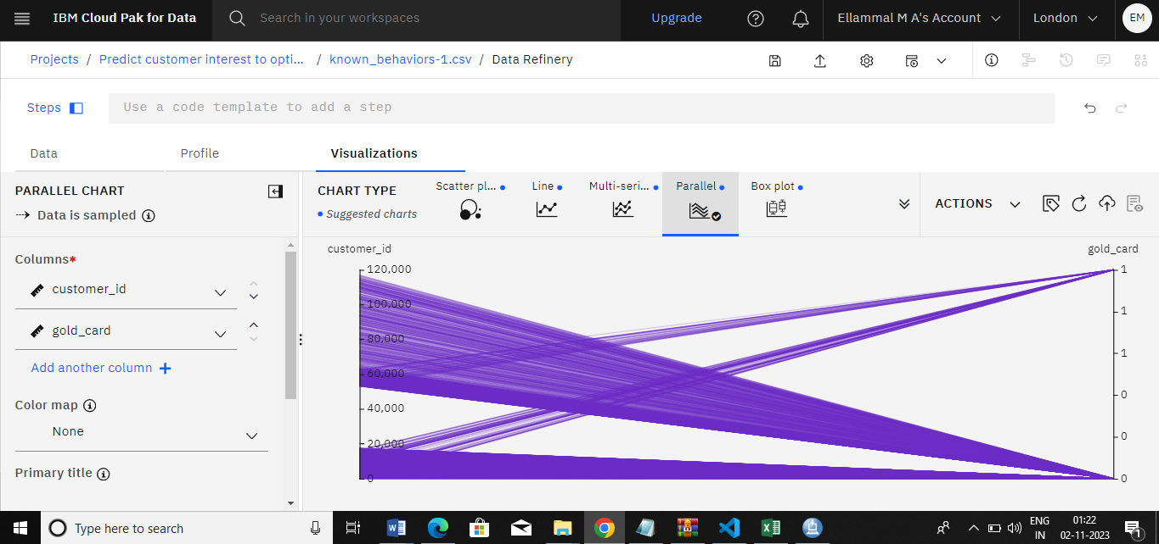

Conclusion
In conclusion, the application of advanced machine learning models for customer churn prediction in telecommunication companies represents a pivotal step towards fostering customer retention, optimizing business operations, and maximizing profitability. the synergy of data-driven insights, predictive analytics, and proactive customer engagement offers a compelling avenue for telecommunications companies to mitigate the challenges of customer attrition. By harnessing the power of data, implementing robust machine learning frameworks, and continuously refining predictive models, these organizations can not only identify at-risk customers but also tailor strategic interventions that lead to enhanced customer satisfaction and long-term loyalty, ultimately propelling them towards sustained success in an ever-evolving industry landscape.

